Using the Small Hall Projector

1. Switch on the system
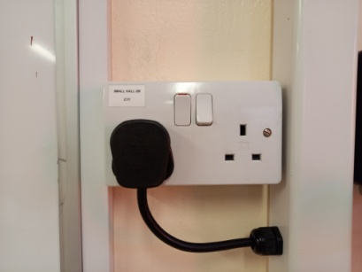

2. Roll the screen down
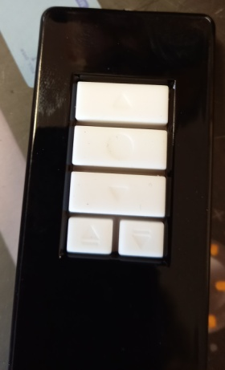
It’s not very clear, but Screen Down is the third button from the top, Screen Up is the top button and the middle of the three is Stop.
3. Switch on the projector using the blue button. It is set for HDMI. Do not use any other buttons.
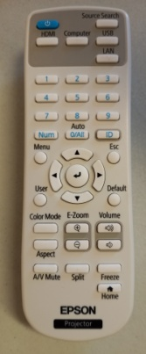
4. Connect the laptop to the projector via the HDMI cable. This will provide sound as well as vision from the laptop.
