Using the microphones
There are two microphones, a hand held microphone and a lapel microphone. They can both be used at the same time. There is also a hearing loop.

1. Switch on the system
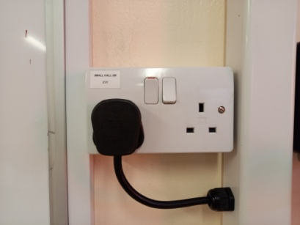

2. To use the Hand Held Microphone
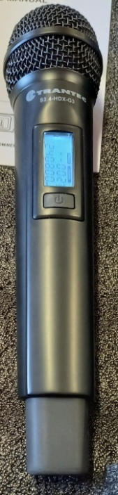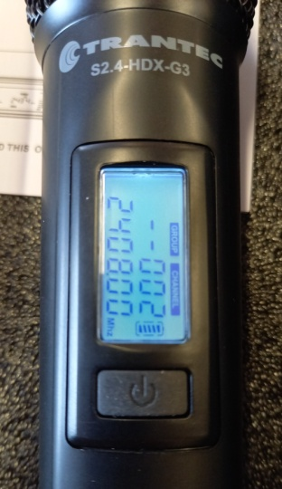
To switch the microphone on, press and hold the On/Off button until the screen comes on. Hold the microphone about 10 cm (4 inches) from the mouth. To switch off, press and hold the On/Off button until the screen goes off.
3. To use the lapel microphone
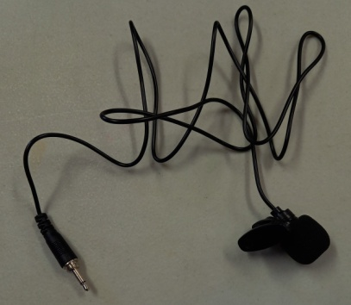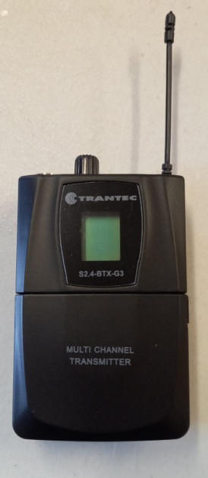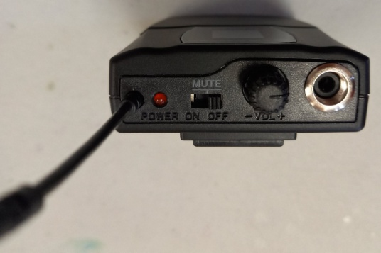
Plug in the microphone into the receiver by inserting the jack into the socket and screwing it in. Fix the microphone to the lapel, it should be about 10 cm (4 inches) from the mouth. Then switch the receiver on. There is a volume control between the socket and the On/Off switch. When finished, switch the microphone off, remove it from lapel and unscrew the microphone from the receiver.

