DISHWASHER OPERATING INSTRUCTIONS
It is not complicated to use, but you must follow the instructions correctly otherwise it won’t work.
NOTE: This is a commercial dishwasher and the water must be heated for 40-45 minutes before use
- Open the dishwasher door and ensure the metal filter is clean and both drain plug (grey plastic tube) and metal filter are in place (see picture).
- Check whether there is water in the floor of the machine; if so, it must be drained first (paragraphs 11 – 13); otherwise it won’t work.
- ENSURE THE GREY TUBE IS THE RIGHT WAY UP – SEE BELOW
Otherwise it won’t work!
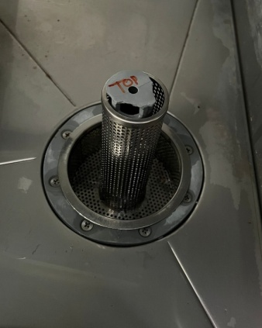
Shaped, narrower end of grey tube uppermost
(the end with the fully open hole should be at the bottom)
- Close door.
- Switch on main isolator switch (left of window).
- Press power button (on left of machine, GREEN Light will come on) to fill dishwasher and commence water heating cycle.
- Wait until ORANGE “Machine Ready” light (on right of machine) is lit.
MACHINE USUALLY TAKES 40 – 45 MINS TO GET HOT
- Scrape food debris into a food waste bag before loading wash tray. Place wash tray inside machine, close door and select either 2 or 3-minute cycle: Cycle timer button: In (light on) = 3-minute wash, Out (light off) = 2-minute wash.
- Press “Start Wash Cycle” button to commence wash cycle; “Start Wash Cycle” light goes off. (Detergent and rinse aid are added automatically).
- When cycle has finished, (“Start Wash Cycle” light comes on), open door with caution (hot water and steam); re-load machine and re-start wash cycle as necessary.
- At end of use, drain machine by removing grey drain plug (leave filter in place) and pressing Power button once; GREEN light will go off. The drain pump will run for about 3 minutes to empty the machine.
- Please remove, clean and replace metal filter inside machine (empty debris into a food waste bag and take it away with your other rubbish).
- Replace the grey drain plug in the filter basket inside the machine.
- Switch off main isolator.

